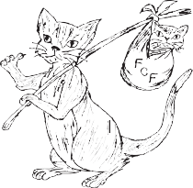
Feral Cat Foundation

SUMMER
2022
An all-volunteer non-profit organization

OUR COMMITMENT
The overpopulation and suffering of homeless and unwanted cats in our society demands a humane solution. Feral Cat Foundation (FCF) accepts the challenge to promote public recognition of this problem, to pursue workable solutions and, without euthanasia, to humanely reduce the population while improving the quality of life for these innocent victims of human neglect.

Yup---there were 9 of them. I counted them three times, just to be sure. Mom looked more than a little dazed at what she had accomplished. She had been through so much in the last 72 hours, and was frantic to get away. So I gave her a bowl of warm food and left her alone with her new family.
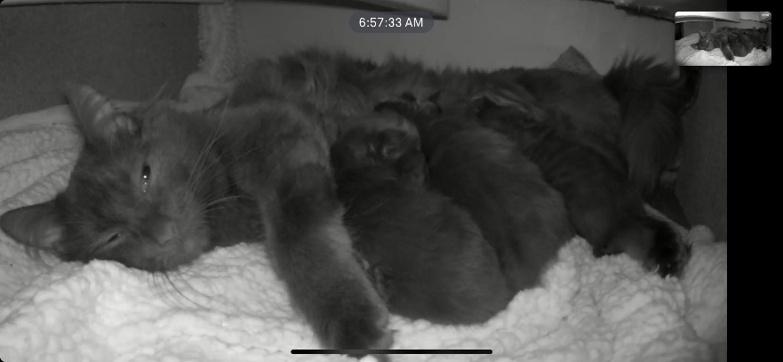
Later that day she was nestled in her box, feeding a mass of furry babies. As I sat down next to her cage, she hissed and bolted, leaving 9 open mouths. I took that opportunity to check out her babies. There were 5 larger kittens—cute as buttons. Then there were 4 very small, very ugly, obviously very premature kittens. This could be difficult.
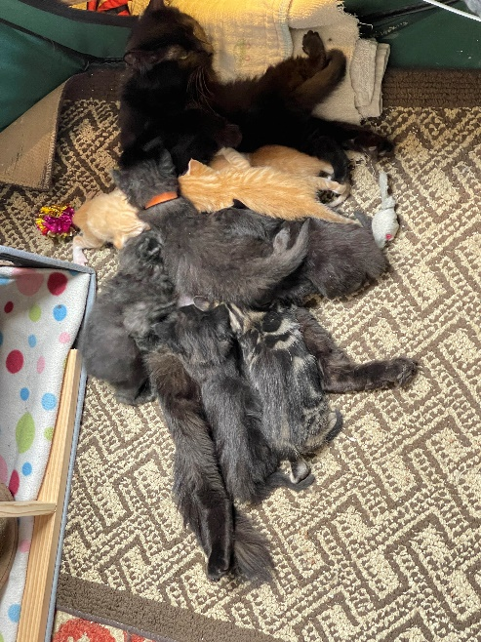
The 4 smaller kittens were weak and hungry, having been pushed aside by the stronger ones. The little ones obviously needed extra help, but from which direction? It was decided that the larger kittens should be supplemented, so that the smaller ones would have the benefit of more available mother’s milk.
Mom was having none of the help she was being offered. She and her foster had to have a good talk, and she finally calmed down enough that her babies could be pulled out of the cage to be bottle fed. The mother accepted that she would need help if her babies were all to survive. And thus began one of the most rewarding journeys a foster can travel.
The littlest ones started improving in a day. The larger kittens were being supplemented 3 times a day, leaving the little ones lots of mother’s milk. At 2 weeks all 9 were wobbling to the front of the cage, their voices raised in loud complaint of empty tummies, even if they had just been fed.
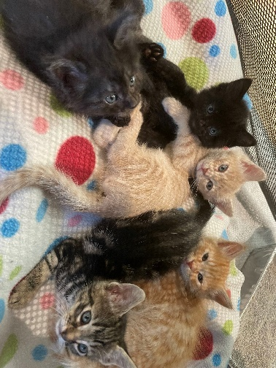
What fun to watch them thrive, especially knowing that almost half of them would not have survived in the open. They grew quickly, learned to walk properly, then run, then climb. They learned to clean themselves, falling over in their first attempts, landing often in the water bowl. They were introduced to canned food at 4 weeks, all 9 trying to stand on the plates at one time. They often wore more than they ate. But mom patiently cleaned them, nurtured them, and taught them the things they would need to know.
The five were beautiful, but the four preemies took a long time to even become cute. Finally, at about 7 weeks, the four started to “pop” out and become more normal looking. What a joy to watch them grow and thrive!
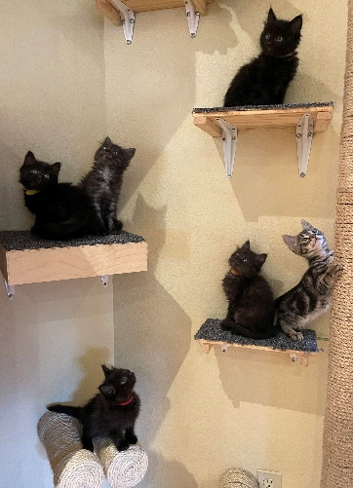
We held our breath when they were spayed and neutered, and cried when they went to their furever homes at adoptions. We miss them, but are happy they are all someone’s Special Friend.
It’s RAFFLE time! The members of Feral Cat Foundation could not do the work we do without your support. Last year FCF spayed and neutered 1800 cats, and found homes for about 300. Our annual raffle is a great way to show your support while having the chance to win one of many fantastic prizes such as a trip to Hawaii or Wine Country or even $1,000 cash! Each book of 6 tickets is $10 and is considered a tax-deductible donation. We are an all- volunteer, donation driven organization. All proceeds from our raffle go directly to help the cats. Your participation in our raffle helps us help the cats. You may call our hotline (925-829-9098) or visit one of our adoption locations for tickets. Thank you for your participation in our raffle.

www.feralcatfoundation.org

